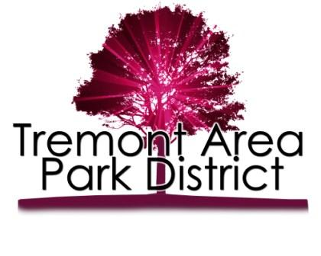
Dear Tremont Area Park District Residents,

We would love to get your thoughts and suggestions about the park district activities and facilities.
Here are a few questions we would appreciate your input on and please rank your interest in the following programs on a scale from 1 – 10 with one being the most interest and 10 the least :

- Youth Programs
□ Dance □Crafts □Movie Nights □Art
□Parent’s Night Out □Preschool Playdays □Soccer □Basketball
□Baseball/Softball □Theatre/Drama □Martial Arts □ SAS clinics
□Babysitting Classes □Exercise Classes □Volleyball □ Holiday programs
Other:

- Adult Programs
□ Dance □ Game Nights □Movie Nights □Family Nights
□Martial Arts □Art/Crafts □Exercise Class □Intramurals
Other:

- Parks
□ Music in the Parks □ Family Nights □Boat Regatta □Pool Family Nights
□Fishing Derby □ □ □
Other:

- Volunteering for TAPD
□ City Park □ Cullinan Park □Tiber Creek Area □North Lake
□Southwest Lake □Southeast Lake □Coaching □Programs
Other:

The Tremont Area Park District Staff and Commissioners appreciate your suggestions and comment and wish to serve you, the community. If you would like to volunteer or serve on a committee to help maintain our parks and programs we would love to contact you.

Name:
Phone (H): (C):
Email:
Interests:

Other suggestion or comments:

Sincerely,
Tremont Area Park Staff and Commissioners

